Broad Band

Introduction

In 1960s people started thinking of potential value in allowing computers to share information on research and development in scientific and military fields. Internet was the result. Leaving what happened in between, the next milestone was in 1965 when Lawrence Roberts connected a computer at Massachusetts with a computer at California over dial-up telephone lines. The feasibility of wide area networking was proved. Defense Advanced Research Projects Agency (DARPA) in 1966 developed plan for ARPANET. The Internet, then known as ARPANET, was brought online in 1969 under a contract let by the renamed Advanced Research Projects Agency (ARPA). The initial interconnection was between computers at four universities in USA.

The Internet matured in the 70's as a result of the TCP/IP architecture replacing the earlier Network Control Protocol (NCP)and universally adopted by 1983.

The National Science Foundation funded NSFNet as a cross-country 56 Kbps backbone for the Internet in 1986. As the commands for e-mail, FTP, and telnetwere standardized, it became a lot easier for non-technical people to learn to use the nets.

So people were able to make good use of the nets - to communicate with people around the world and to share files and resources. An archiver for ftp sites was created in 1989. The commands to search Archie were UNIX commands, and it required some knowledge of UNIX to use it to its full capability. Followed were

Wide Area Information Server (WAIS), which would index the full text of files in a database and allow searches of the files

Gopher, which needed no knowledge of UNIX or computer architecture to use.

VERONICA searchable index of Gopher menus.

A real significant event took place in 1989 making the nets easier to use. A protocol based on hypertext was evolved. Hypertext used a system of embedding links in a text to link to other text. Although started before Gopher, it took much time to develop. It was termed as World Wide Web in 1991. The development of Mosaic graphical browser gave the protocol its biggest boost.

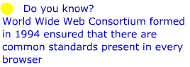 | This was followed by Netscape Browser and Microsoft Internet Explorer.

Initially the Internet was funded by the government and it was limited to research, education, and government uses and the traffic was constrained to NSFNet backbone. Delphi was the first to offer commercial online service. Internet access was given to its subscribers in 1992. Internet entered into commercial arena fully with the release of Windows 98 in June 1998 with the Microsoft browser well integrated into the desktop.

Now people share the news and views, convey their feelings and emotions and express their hopes and dreams through internet. Internet has become the part of life. The content of internet has moved from text to converged multimedia. But the dial up modems and links with 56K are not fast enough to carry multimedia, such as sound and video except in low quality.

Then how the Internet will or shall take shape?

The delay in establishing connection which is normally unavoidable in dial-up should be avoided i.e. the internet connection should be ‘always on’. The bandwidth should be able to carry the data, sound and video in a good quality to the customer.

These paved the way to ‘Broadband’
What is Broadband?

Why Broadband access to Internet?

We are in a world where the economy is controlled by information and technology. A major part of global economic structure is affected by the innovations in computers and in telecommunications. The Internet plays a significant role in shaping the new economy. The Internet has become a daily source for e-mail, shopping, research, and news rather than a tool of academics and researchers what it used to be. Advertisements in television and newspaper carry the E-mail and Web addresses of business firms. Shopping bags are no exception. Firms continue to communicate and conduct business on a global basis through Internet without regard for location or asset size. The importance of internet has increased multifold As the Internet market continues to explode, the demand for greater bandwidth and faster connection speeds has also increased.

Several technological approaches were developed to provide higher bandwidth to enable speedy access to internet. Broadband access is one of the most important internet access technology, drawing the attention of telecom equipment manufacturers, service providers, content providers and cable operators The influence of the Internet and the introduction of many Internet-ready applications have fueled the demand for broadband access.

The most important issue on our agenda today is broadband. We want four things for consumers in the broadband world. We want fast deployment. We want ubiquitous deployment. We want competitive deployment. And we want open deployment." --Kennard (Former Federal Communications Commission (FCC) Commissioner)

To gain the most out of what the Internet has to offer, broadband access to the Internet is a must.

Last mile Technologies

"The last mile is a huge challenge for carriers around the world. It is a critical link and one that is vital for the uptake of future broadband network services"--Hugh Bradlow, Chief Technology Officer, Telstra.

While the speed and capacity of global telecoms infrastructures have grown exponentially during the past few years, carriers still find themselves constrained by an old bottleneck. The last mile, that final leg of a telecoms network between a local exchange and a subscriber, still represents a considerable challenge for operators trying to deliver true broadband services.

Last mile technology is a term used for the local transmission loop that connects the end user to the nearest telephone exchange. Last-mile technology is any telecommunications technology, such as wireless radio, that carries signals from the broad telecommunication along the relatively short distance (hence, the "last mile") to and from the home or business. Or to put it another way, the infrastructure at the neighborhood level. In many countries, last-mile technology represents a major remaining challenge to high-bandwidth applications such as on-demand television, fast Internet access, and Web pages full of multimedia effects.

Today, in addition to "plain old telephone (dial-up) service", last-mile technologies to deliver voice, data, and TV can include

ISDN, a somewhat faster technology than regular phone service,

Digital Subscriber Line (DSL) over existing telephone twisted pair lines,

Cable and the cable modem for data using the same installed coaxial cable that already is used for television,

Wireless, including services such as DirecTV (less frequently used because of the installation expense),

Optical fiber

To overcome these restrictions, a range of technologies is emerging, designed to remove the bottleneck and improve user experiences. Some augment existing infrastructure while others bypass it completely. "There is no single answer to the last-mile challenge," says Bradlow. "It is a matter of using the best technology for a particular situation. We are going to see some interesting changes during the next few years."

Last Mile Connections provides new and innovative ways for bandwidth intensive users to address their network interconnection challenges and delivers a range of better, more cost-efficient services. Last Mile Connections brings together buyers and sellers more efficiently than ever before “Access technology” addresses the means by which the subscribers get connected with the service providers network.
Last Mile technologies are:
1. Cable Modem
2. DSL
3. Wireless Ethernet
4. 3G Cellular Wireless
5. Fiber

Cable Modem Basics

Current Internet access via a 28.8–, 33.6–, or 56–kbps modem is referred to as voiceband modem technology. Like voiceband modems, cable modems modulate and demodulate data signals. However, cable modems incorporate more functionality suitable for today's high-speed Internet services.

Cable modem is capable of delivering up to 30 to 40 Mbps of data This is approximately 500 times faster than a 56–kbps modem

In the conventional case the TV set receives the signal directly from the cable operator through Co-axial cable as shown in the figure1. When internet data combined with the TV signal is received a spilliter is required to seperate the signals(figure 2).
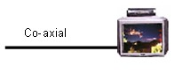  FIGURE 1 | 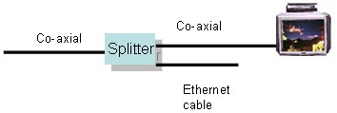FIGURE 2

The seperated data is taken through co-axial cable to the cable-modem which in turn is connected to the PC through Ethernet/USB port

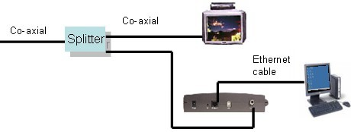

A subscriber can continue to receive cable television service while simultaneously receiving data on cable modems to be delivered to a personal computer (PC) with the help of a simple one-to-two splitter

A device called a cable modem termination system (CMTS), located at the local cable operator's network hub, controls access to cable modems on the network.It is for support of data services that integrates upstream and downstream communication over a cable data network. The number of upstream and downstream channels in a given CMTS can be engineered based on serving area, number of users, data rates offered to each user, and available spectrum

A cable headend (combiner)combines the downstream data channels with the video, pay-per-view, audio, and local advertiser programs that are received by television subscribers. The combined signal is then transmitted throughout the cable distribution network.

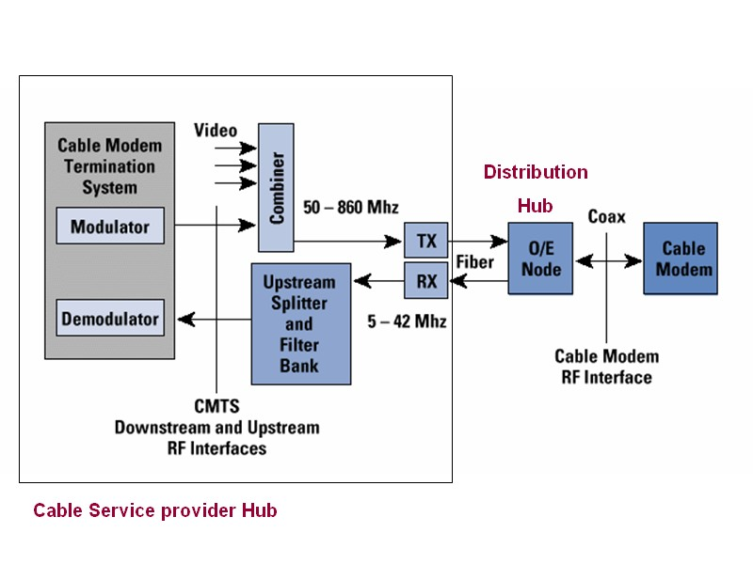

Traffic is routed from the CMTS to the backbone of a cable Internet service provider (ISP), such as Road Runner, which, in turn, connects to the Internet. With newer cable modem systems, all traffic from the CMTS to the cable modem is encrypted to ensure privacy and security for users.

To try to promote cable modem rollouts, as well as relieve technological confusion, CableLabs, an industry trade organization, drafted a standard for cable modem products in 1996 called DOCSIS (Data Over Cable Service Interface Specification). The standard was developed to ensure that cable modem equipment built by a variety of manufacturers is compatible, as dial-up modems are.

Today, CableLabs continues to manage a rigorous testing process for DOCSIS cable modems, stamping the products that pass the test "CableLabs Certified." Many companies like 3Com, Cisco Systems, Com21, Motorola, Nortel Networks, Philips, Thomson, Toshiba, Samsung and Sony are marketing DOCSIS cable modems.

To try to promote cable modem rollouts, as well as relieve technological confusion, CableLabs, an industry trade organization, drafted a standard for cable modem products in 1996 called DOCSIS (Data Over Cable Service Interface Specification). The standard was developed to ensure that cable modem equipment built by a variety of manufacturers is compatible, as dial-up modems are.

Today, CableLabs continues to manage a rigorous testing process for DOCSIS cable modems, stamping the products that pass the test "CableLabs Certified." Many companies like 3Com, Cisco Systems, Com21, Motorola, Nortel Networks, Philips, Thomson, Toshiba, Samsung and Sony are marketing DOCSIS cable modems.

Digital Subscriber Loop

The Digital Subscriber Line (DSL) technology is widely regarded as a vehicle for offering wired broadband services to the mass market. The services include high-speed access to the Internet, voice and telephony services, interactive video services, e-commerce, messaging, alerting and other multimedia services. Success of the Internet and the World Wide Web has created the market demand and high expectations for high-speed data services through DSL
Twisted pair - voice 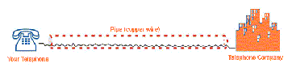 | Twisted pair - voice and data 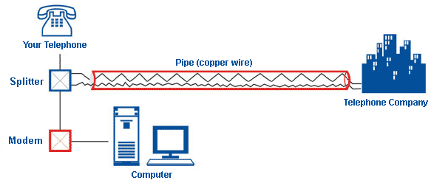

It uses the existing copper pair for providing Broadband. The previous diagram showed how the twisted pair is used for transmitting voice and data. The DSL technology is now mature, poised for rapid deployment and industry growth in the near future. There are number of DSL types available to Address the various network environments and applications in the light of trade-offs between rate and reach

HDSL -- High-rate DSL

ADSL-- Asymmetric DSL

SDSL – Symmetric DSL

RADSL – Rate Adaptive DSL

High Rate DSL

The initial introduction of DSL was via HDSL as a replacement for T1/E1 high capacity (then referred to as Hi-Cap service) interconnection of corporate data networks. Similar to T1/E1 links, an HDSL line uses a 4-wire interface to connect HDSL modems. The market expectations for HDSL technology were economic replacement of T1/E1, private data lines, elimination of line conditioning, extension of loop length, automated provisioning, and enhanced performance monitoring. Please note that all of these expectations were strictly service provider-oriented and resulted in a successful rollout in the international markets. By 1990/1991 HDSL technology gained a significant mind-share and market-share in Hi-Cap replacements.

ADSL (Asymmetric Digital Subscriber Line)

Asymmetric Digital Subscriber Line (ADSL) technology was first introduced in 1992 as a system capable of delivering Video-on-Demand (VoD) service over telephone networks. ADSL utilizes the same twisted two-wire facility (called the subscriber loop) as the traditional telephone service. The traditional telephone service is often referred to as “Plain Old Telephone Service” or POTS. With the initial system architecture and design of ADSL, the same twisted pair could simultaneously support both POTS and data. This is made possible due to a frequency multiplexing technique that supports POTS in the base band and data in a high frequency band above the telephone service.

The ADSL data service is asymmetrical, in that, it has a higher downstream data rate (up to 6 Mbps towards the subscriber) than the upstream data rate (up to 640 kbps towards the service provider). The main objective is to use ADSL as a technology choice for offering VoD service. In 1994 it was proved that ADSL technology could be used to offer high speed data services including video. (Click to view flash movie on speed comparison). Mass-market success of the Internet technologies – World Wide Web, the Internet browser, and the Universal Resource Locator (URL) led to high residential as well as business demand for broadband services.

SDSL(Symmetric DSL)

A variation of ADSL technology more suitable for the T1/E1 market was envisioned via a symmetric offering of ADSL, known as SDSL. The SDSL technology was envisioned to be a 2-wire equivalent to the 4-wire HDSL service. The market expectations were Ubiquitous and consistent high-speed data offering, support for internet access protocols, automated provisioning, dynamic access to services without requiring telephone company intervention, and inexpensive pricing to enable a wider deployment of service. Note that all of these expectations have shifted from service provider

Fiber To The Home - FTTH

Fiber to the home (FTTH) is the ideal fiber-optics architecture. In this architecture, fiber deployment is carried all the way to the customer’s home (premises).This chapter will address the solution, which is a fiber-optics architecture called FTTH

FTTH has been developed in response to several residential access market drivers, including the following:

The Internet explosion, second line growth, the desire for higher speeds, alternative strategies such as voice over DSL (VoDSL), voice over IP (VoIP), voice over ATM (VoATM), and cable modems

The increased competition in the market due to the growing number of competitive local-exchange carriers (CLECs), an increase in services offered by application service providers (ASPs), and deregulation and pending Federal Communications Commission (FCC) rulings

The declining costs of optical equipment Technology
How FTTH works
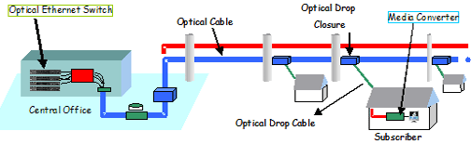

How FTTH works

In an FTTH system, equipment at the head end or CO is interfaced into the public switched telephone network (PSTN) and is connected to ATM or Ethernet interfaces. Video services enter the system from the cable television (CATV) head end or from a satellite feed.

All of these signals are then combined onto a single fiber using WDM techniques and transmitted to the end user via a passive optical splitter. The splitter is typically placed approximately 30,000 feet from the central office (CO). The split ratio may range from 2 to 32 users and is done without using any active components in the network. The signal is then delivered another 3,000 feet to the home over a single fiber. An ideal FTTH system would have the ability to provide all of the services users are currently paying for, such as circuit-switched telephony, high-speed data, and broadcast video services.

At the home, the optical signal is converted into an electrical signal using an optical electrical converter (OEC). The OEC then splits the signal into the services required by the end user. Ideally, the OEC will have standard user interfaces so that special set-top boxes are not needed to provide service. These interfaces would include RJ11 jacks for telephony, RJ45 jacks to high-speed data, and 75 ohm coax ports for CATV and DBS services.

The Advantages of FTTH

It is a passive network, so there are no active components from the CO to the end user. This dramatically minimizes the network maintenance cost and requirements, as well as eliminating the need for a DC power network.

It is a single fiber to the end user, providing revenue-generating services with industry standard user interfaces, including voice, high-speed data, analog or digital CATV, DBS, and video on demand.

FTTH features local battery backup and low-power consumption.

FTTH is reliable, scalable, and secure.

The FTTH network is a future-proof architecture.

Upstream 80Mbps and Downstream ranging about 35-40Mbps

Shared.. Hence precaution for security should be taken care of

Wireless Technology

Wireless broadband technology sends data over a 'wireless' communications network, typically using radio frequency.

These technologies are a strong and popular platform for delivery of high-speed Internet services and wireless broadband, is emerging as a legitimate local access platform for the delivery of high-quality digital data, video and voice services.

In many regional areas where telecommunications infrastructure such as fibre optic or coaxial cable is limited, wireless technologies offer a competitive broadband access solution.Rather than stringing thousands of miles of fiber, coax or twisted-pair wiring, a wireless operator installs a headend and transmission tower and is open for business.

Wireless technologies can provide area coverage from anywhere between 5km to 40km depending on the local terrain and strength of the transmitter signal.

The advantages of wireless broadband:

Access - a wireless network provides high-speed access to the Internet without the need for expensive wire or cable infrastructure.

Flexibility - the capacity (number of customers) of a wireless network can be expanded when required.

Versatility - wireless services are suitable for both lightly populated areas, but can also be deployed to provide customised services in highly populated areas.

Costs - without the need for expensive equipment and/or infrastructure, the cost of wireless broadband products can be lower than wired products.

Some wireless technology may require line-of-sight between the transmitting and receiving points. This can be a limitation in mountainous areas and 'Unscheduled' heavy use on the network can use up valuable bandwidth, or cause interference on occasions

Another thing in wireless technologies is the geographic distance they are to serve. The term "hot spot" (referring to a small geographical area of coverage for example, a coffee house) has entered into the standard terminology of the wireless data networking industry. But equipment useful for hot spot coverage will not accommodate the needs of the "last mile" application. A bit of a misnomer, the "last mile" has progressed to mean anything from the "last 50 meters/feet" to the "last 20 miles"

No one product can serve all the myriad of applications and as a result there are now several wireless technologies to choose from. These technologies fall into two categories: standard technologies such as 802.11 (WiFi) and 802.16 (WiMax) and proprietary technologies. Each technology has its own advantages and disadvantages

Wi-Fi

Short for wireless fidelity, Wi-Fi technologies include the approved IEEE 802.11a, b and g specifications, as well as the
yet-to-be-ratified 802.11n specification. Wi-Fi is the first high-speed wireless technology to enjoy broad deployment,
most notably in hotspots around the world – including homes and offices, and increasingly cafes, hotels, and airports.

Wi-Fi hotspots became popular almost immediately and have been applauded by road warriors for their ability to
improve productivity. Wi-Fi is limited, however, by its range: high-speed connectivity is possible only as long as a user
remains within range of the wireless access point, which is optimum within 300 feet.

Wi-Fi was one of the earliest high-speed wireless data technologies and now benefits from a broad availability of
supporting products and technologies. Some of the newest platforms even support multiple Wi-Fi standards (e.g. 802.11a, b and/or g) for compatibility among several wireless networks.

WiMAX

WiMAX is an emerging technology that will deliver last mile broadband connectivity in a larger geographic area than
Wi-Fi, enabling T1 type service to business customers and cable/DSL-equivalent access to residential users.
Providing canopies of coverage anywhere from one to six miles wide (depending on multiple variables), WiMAX will
enable greater mobility for high-speed data applications. With such range and high throughput, WiMAX is capable
of delivering backhaul for carrier infrastructure, enterprise campuses and Wi-Fi hotspots.

WiMAX will be deployed in three phases. Phase one will see WiMAX technology using the IEEE 802.16d specification
deployed via outdoor antennas that target known subscribers in a fixed location. Phase two will roll out indoor
antennas, broadening the appeal of WiMAX technology to carriers seeking simplified installation at user sites.
Phase three will launch the IEEE 802.16e specification, in which WiMAX-Certified* hardware will be available in
portable solutions for users who want to roam within a service area, enabling more persistent connectivity akin to
Wi-Fi capabilities today.

ADSL architecture

In POTS, with the available voice band of 3.5kHz and allowed S/N = 30dB, the theoretical upper limit on data rate will be roughly 35Kbps. Copper access lines can pass frequencies into the MHz region. This feature is precisely what ADSL focuses on.

ADSL technology offers the asymmetric bandwidth characteristics that are 1.544-8.448Mb/s in downstream and 32-768kb/s in the upstream. This feature fits in with the requirements of client-server applications, in which the client typically receives much more data from the server then he is able to generate

ADSL System Architecture

The ADSL functions at the network end (central office end) are performed by an ADSL Terminal Unit-Central office type (ATU-C) together with a splitter function (S-C). The ATU-C interfaces with the network switching, transport, and multiplexing functions and network operations. The ATU-C functions are usually integrated within a higher level network element, e.g. DSL access multiplexer (DSLAM).

Although copper pairs are widely available, several line conditions may prevent the delivery of ADSL: first, if the telephone line to the customer premises is longer than 5.5km, second, existing of the load coils or an excessive number of bridged taps and third, that some portions of the telephone line is carried to the premises on fiber optic cable .

DSLAM contains the access interface (network termination – NT) to the appropriate next device in the network, e.g., Tier2, Tier1 Switch etc. ADSL functions at the customer end (remote end) are performed by an ADSL Terminal Unit-Remote end type (ATU-R) together with a splitter function (S-R). At the customer premises, ATU-R may present the interfaces to the local distribution for broadband services via service modules (SM). The SM contains necessary decoders and terminal interfaces for the given service and customer control interfaces.

Splitters are three node devices that allow the telephony signals and the ADSL signal to reside on the same copper loop without interfering one with the other. The splitter provides a low pass filter to the basic voice and control telephony signal (below 4 kHz) and a high pass filter for the ADSL signals, starting approximately at 25 kHz or above. Most POTS splitter designs are passive, that is without powering requirements. The advantages of passive filters are in their reliability, because they enable continuous telephone service even if the modem fails (for example, due to a power outage).
The connectivity architecture of DSLAMs is as shown in figure. The DSLAMs are connected to the Tier 2 Switches and again, the Tier2 switches are connected to Tier1 Switch. In turn the Tier1 Switch is connected to "Broadband Remote Access Server"(BBRAS) which is routed to core router through which it gets access to the International Gateway.
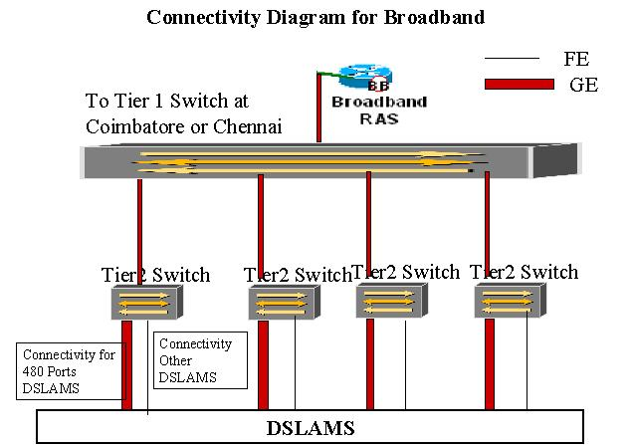

The below diagram shows the connectivity portion of DSLAM with the Tier2 switch. If the distance between the DSLAM and the Tier2 switch is less than 10 Kms, then Dark Fibre could be used for connectivity. (Dark fibre means a spare fibre). If the distance exceeds 10 kms, then we can use the STM medium with electrical to optical converters at both the ends, as both DSLAM as well as Tier2 switch has optical interface whereas the output from STM is electrical.
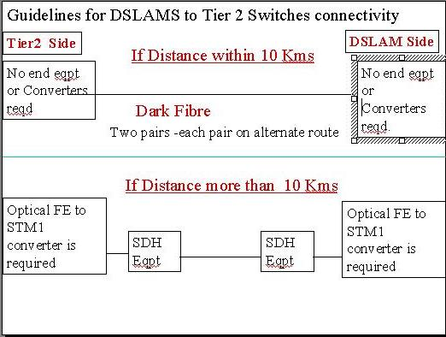

There are a large number of different kinds of servers that can be accessed by an ADSL system Video on Demand service is one of the most interesting aspect of ADSL. By using MPEG coded video it is possible to deliver video quality movies over existing copper loops to customers. A video quality can be achieved by only 1.5 Mbps data rate. Together with pure VoD services there might exist combined movie information and advertiser services in which commercial and non commercial information that providers and advertisers can deliver their information.
ADSL connectivity, in a Global view
Globally,a flexible way to connect various servers to corresponding applications device is to use ATM switches. Local ATM switch is connected to an access module in a telephone central office. The access module is used to connect the ATM network to phone lines. In the access module ATM data stream from server is decomposed and routed to the corresponding phone lines
See below the connectivity architecture that is used normally in other Telcos where ATM/FR switches are prevailing.
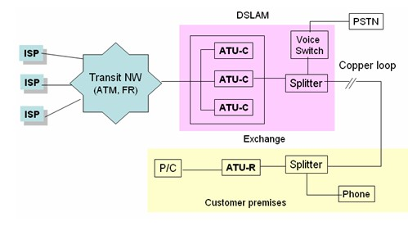

ADSL Coding Techniques

All signals sent over conventional pair-cable telephone lines are subject to line attenuation, dispersion and electrical noise. Line attenuation and some forms of in-band noise both increase with frequency. Consequently, modern high-rate digital systems require special spectrally efficient modulation techniques to achieve high-quality transmission performance. DSL normally follows two types of modulation: 1) Carrier less Amplitude Phase modulation (CAP) and 2) Discrete MultiTone Modulation (DMT)

Carrierless Amplitude Phase modulation(CAP)

CAP stands for carrier less amplitude and phase modulation. It uses the entire frequency range (i.e. all of the 138 to 1100 KHz for downstream, or all of the 3.4 to 138 KHz for duplex) for sending individual symbols, i.e. it sends them one at a time. The large frequency range permits the symbols to be more compact in time, so the rate at which they can be sent is higher. Its set of symbols was concocted in a way that yields a large number of well-separated symbols First, two orthogonal symbols were chosen, then others were formed by adding together different amounts of these, where the amounts are evenly spaced. This gives a "grid" of well-spaced symbols. For instance, AT&T's "64 CAP" uses 8 amounts of each of the two symbols, to produce 64 symbols total:
 | 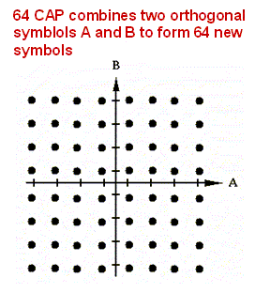 | These aren't all orthogonal, but they're about as far apart as can be without using some complicated and impractical scheme for making combinations  Because the symbols are formed using the entire frequency range, rather than being superimposed on a carrier wave, it's called carrierless. But it's not baseband -- its frequencies don't go all the way down to zero. Everything below 4.3 KHz and above 138 KHz is filtered out of the duplex channel and everything below 138 KHz from the downstream channel. This means that the symbols had to be chosen so they didn't rely on any of the lower frequencies to make them distinguishable

Discrete Multi-Tone modulation (DMT)

The standard ADSL system uses 256 channels for the downstream data and 32 channels for the upstream. All channels have bandwidth of 4.3 kHz and frequency difference between two adjacent channels is also 4.3kHz. Each channel can be modulated with QAM at up to 15 b/Hz. Theoretically, DMT could transmit 15.36 Mb/s over a line of zero length. Real lines and real implementation, of course, are not so promising, but rather than using adaptive equalizers to compensate for variations in line attenuation (single carrier systems), DMT spreads data over all channels according to the S/N ratio in each one

DMT divides it into 256 sub-channels and optimizes the data rate for each sub-channel

DMT has been accepted as the standard by ETSI

During initialization a DMT modem measures the SNR per channel and makes optimum use of the line by making optimum use of each subchannel. The available spectrum ranges from about 25 kHz to 1.1MHz. Support of bidirectional channels is provided by dividing the available bandwidth by Frequency Division Multiplexing (FDM), when non-overlapping bands are assigned for the downstream and upstream data

Another method is the echo cancellation in which bi-directional streams are assigned with the overlapping. At present only multicarrier ADSL modems have been implemented with echo cancellation.

Spectrum of Copper pair used in last mile
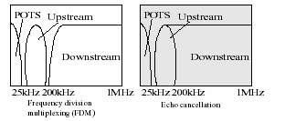 | 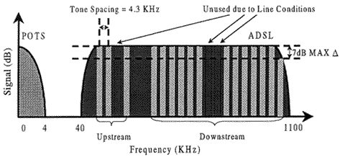

There are a total of 256 DMT tones, separated by 4.3125 kHz, each with a different centre frequency, fc. Since the POTS channel resides at the lower end of this spectrum, only tones 7 -255 are available.

Full-rate ADSL:

The downstream uses DMT tones 7 - 255 (echo cancellation) or 32 - 255 (FDM). The upstream channel uses tones 7 - 31. Bit loading is adaptive and varies from 2 to 15 bits per tone (subchannel) depending on the relative noise of each carrier. When high noise levels are detected in a given subchannel, the DMT modem can shut down a particular subchannel altogether.

G.lite:

For the reduced bandwidth of G.lite, there are a total of 128 DMT tones. The downstream channel uses 7 - 128 tones and the upstream, 7 - 32. Bit-loading varies from 2 to 8 bits per symbol.

The ADSL data rates and bandwidths

G.DMT= ITU G.992.1
 |  | Bandwidth | Data Rate
POTS |  | 300 Hz to 3.4 kHz
Downstream (DS) |  | 25 kHz to 138 kHz (7 to 31 DMT tones) | 1.5Mbps – 8 Mbps
Upstream (US) |  | 138 kHz to 1.1 MHz  (FDM, 32 - 255 DMT tones)  25 kHz to 1.1 MHz  (Echo Cancellation, 7 – 255 DMT tones) | 32 kbps - 768 kbps

G.lite = ITU G.992.2 (Splitter less- low power standard)
Downstream (DS) |  | 25 kHz to 138 kHz | 64 kbps - 1.5 Mbps
Upstream (US) |  | 138 kHz to 550 kHz | 16 kbps - 368 Kbps

ADSL Modem

The ADSL transmission signal is modulated onto discrete multi-tones (DMT). As already seen, there are 256 independent parallel sub channels available in the 1.1MHz ADSL bandwidth. Each sub channel is separated by approximately 4 kHz and has a distinct carrier frequency in the center of this 4 kHz band. While DMT is the physical transmission level, framing and encoding (error correction) occurs at a higher level. The modulation technique used in each of the discrete multi-tone (DMT) channels is Quadrature Amplitude Modulation (QAM) where both the phase angle and the amplitude of the carrier band are modulated to represent the information being transmitted.

In a typical ADSL modem, the main sections are

The Digital Interface (e.g. ATM)

The Framer/FEC plus Encoder/Decoder

The DMT Modulator

The AFE (Analog Front End)

The Framer multiplexes serial data into frames, generates FEC (Forward Error Correction), and interleaves data. FEC and data interleaving corrects for burst errors. This allows DMT-based ADSL technology to be suitable for support of MPEG-2 and other digital video compression techniques

For the transmit signal

The Encoder encodes frames to produce the constellation data for the DMT Modulator. It assigns the maximum number of bits per tone (based on measured SNR of each carrier) and generates a QAM constellation where each point represents a digital value. Each constellation point is one of N complex numbers, x + iy, where x and y are the phase and amplitude components. The summation of bits in all carriers, multiplied by the frame rate (4kHz), represents the data rate

For the receive signal

The Decoder converts QAM symbols back into the data bitstream.
In the DMT Modulator, a frequency domain processor implements FFT/IFFT and associated processing. In the transmit path, the Inverse Fast Fourier Transform (IFFT) module accepts input as a vector of N QAM constellation points and duplicates each carrier with its conjugate counterpart so the 2N output samples are real. The 2N time domain samples have the last 2N/16 samples appended as a cyclic prefix, and are then delivered to the DAC (Digital to Analog converter). The set of time domain samples represents a summation of all the modulated sub channels, for the duration of one data frame.

In the receive path, the first 2N/16 samples from the ADC (Analog to Digital Converter) Cyclic prefix are removed. The FFT (Fast Fourier Transform) module transforms the carriers back to phase and amplitude information (N complex QAM symbols). Correction for attenuation of the signal amplitude and phase shifts (i.e. overall distortion) is implemented. If the QAM constellation is thought of as points in a grid where rows and columns represent phase and amplitude information respectively, then the grid effectively rotates reference to the constellation points to correct for these distortions.

The time-domain unit of the DMT Modulator implements digital filtering (interpolation and decimation) and echo cancellation. For echo cancellation, an inverted replica of the Tx signal that leaks into the receiver (AFE ADC) is generated. The latter effectively subtracts this near-end replica and the far-end signal can then be processed to remove any remaining line-induced noise sources.

The AFE converts the digital transmit bit stream to analog via dual DACs. In ATU-R configuration, the second DAC channel is used to transmit and loop back the echo replica. In the receive path the signal from the line is converted back to digital via the ADCs. The AFE interfaces to the line via a hybrid circuit

Digital Subscriber Line Access Multiplexer (DSLAM)

A DSLAM is configured as typical telephone exchange equipment with the traditional rack and panel structure and stringent operational environment requirement for a maximum capability of 480 ADSL lines. A DSLAM can accept different flavors of DSL line cards. A DSLAM is designed to be connected to a Tier 2 Switch. The ADSL version now used can be upgraded to ADSL2+ in future by way of software upgrade to DSLAM and CPEs.

For TCP/IP-based data traffic, the dedicated digital interface might not be efficient and necessary. Therefore, all ADSL channels can be first statistically multiplexed through a local area network (LAN) at the exchange before being connected to the backbone data network. A LAN interface is required for each ADSL transceiver. The traffic external to the LAN is connected to a public or private computer network through a router. The concentrated data traffic might or might not be connected to the computer network through a digital switch. Because all ATU-Cs are close to each other and the LAN is only served as a traffic concentrator, the function of LAN and router can be combined to form a special purpose ADSL ATU-C concentrator.

Point to Point Protocol Over Ethernet(PPPOE)

Point-to-Point Protocol over Ethernet is a proposal specifying how a host personal computer (PC) interacts with a broadband modem (i.e. xDSL, cable, wireless, etc) to achieve access to the growing number of High-speed data networks. Relying on two widely accepted standards, Ethernet and the point-to-point protocol (PPP), the PPPoE implementation requires virtually no more knowledge on the part of the end user other than that required for standard Dial up Internet access.

In addition, PPPoE requires no major changes in the operational model for Internet Service Providers (ISPs) and carriers. The significance of PPP over Ethernet has to do with its far greater ease of use versus competing approaches. By making high-speed access easier to use for end consumers, and more seamless to integrate into the existing infrastructure for carriers and ISPs, PPPoE could speed the widespread adoption of High-speed access services

Also, PPP over Ethernet provides a major advantage for service providers by maximizing integration with - and minimizing disruption of - service providers' existing dial network infrastructures. Through tight integration with existing back office automation tools that ISPs have developed for dial customers, PPPoE enables rapid service deployment and cost savings. From authentication, accounting and secure access to configuration management, PPPoE supports a broad range of existing applications and services.

Why would PPPoE be used?

PPPoE is used to allow Internet Service Providers (ISPs) the use of their existing Radius authentication systems from their Dial-Up service on a Broadband / Ethernet based service. Dial-Up is PPP; most broadband connections are Ethernet, hence Point to Point Protocol over Ethernet. It also allows for ISPs to resell the same line multiple times. IE: Rated services, Broadband specific content (movies, etc.), metered services, etc

Customer Premises - Connectivity

Hardware recommended

RAM (128 MB & above)
HDD (Min Free Disk Space 500 MB)
LAN card for ADSL Router and
The requisite port is to be got installed by customer at his own cost from PC vendor/ supplier
Operating System:- Windows 98 & above and Operating System drivers
ADSL modem, splitter

Hardware recommended

RAM (128 MB & above)
HDD (Min Free Disk Space 500 MB)
LAN card for ADSL Router and
The requisite port is to be got installed by customer at his own cost from PC vendor/ supplier
Operating System:- Windows 98 & above and Operating System drivers
ADSL modem, splitter

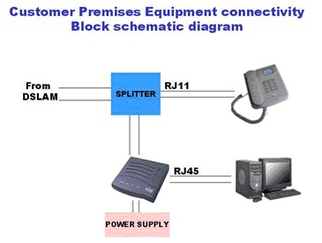
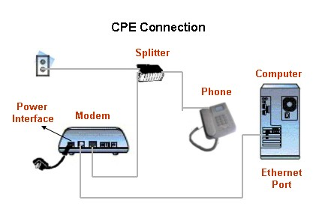

ADSL-Configuration

Unzip the zipped RASPPPoE folder to a temp directory of your choice

Right click on "Network Neighborhood" (in ME "My Network Places"). Choose "Properties" Click "Add..."

Select "Protocol". Click "Add..." . Select "Have Disk". .Select "Browse" Then choose the folder you unpacked the RASPPPoE programs to. Then select any one of the INF files, it does not matter which one Click "OK“. Then "OK" again

In the "Select Network Protocol" window make sure "PPP over Ethernet Protocol" is highlighted and click "OK". .Click "OK" on "Network" window. Click "Yes" to Reboot.

Go to your "Start" menu, and then choose "Run". Type in RASPPPoE and click "OK“
"RASPPPoE" window opens. Click Exit

Double click the Dial-Up short cut on your desk top

Enter your userid as provided by your ISP

Note: you may need to include your ISP's domain as part of your userid

